**Project Specification Document for the Course**

**"Application Development in the GIS Field"**

**Back On Track**



**מגישים :**

**Tom Eliasi – 206484263**

**Ofir Suissa – 322769415**

**Nave Mano - 206781452**

* **General Background**

During the "Iron Swords" War and the evacuation process of residents from the northern and southern regions, many businesses faced significant financial challenges and struggled to maintain customer connections. The impact of the war highlighted the necessity of providing accessible information about these businesses and offering supportive tools to aid their recovery.

* **Project Objective**

Development of an interactive GIS application called "Back on Track," enabling the public to locate businesses impacted by the war and supporting their economic recovery. The application will provide filtering options based on geographic location, business type, operating hours, child-friendliness, discounts, or special offers, among other criteria.

* **System Description**
* **3.1 Application Nature**
* 3.1.1 **Application Type**: The application "Back on Track" will be developed as a responsive web application using HTML, CSS, and JavaScript for the frontend. The server-side logic will utilize Node.js to handle requests and manage data flow efficiently.
* 3.1.2 **Geographic Component**: The application will employ the Leaflet.js library for interactive map rendering and use OpenStreetMap (OSM) as the mapping service. Geolocation APIs will enable the app to detect the user's location and display relevant businesses dynamically.
* 3.1.3 **Database**: The project will utilize a GeoJSON file to manage spatial and attribute data of businesses. The data will be enriched and regularly updated using scraping tools like Puppeteer, combined with the Geopy library for geocoding. For parsing external datasets, the PapaParse library will process CSV inputs when necessary.
* **3.2 System Users**
* 3.2.1. **General Users** – The general public can access the application without the need for registration or login, perform searches, and use the offered filters. If a user wants to rate a business or leave a review, they will need to register for the application.
* 3.2.2. **Business Owners** – Affected business owners can register and add their business details to the application, update the information as needed, and highlight special offers or services.
* 3.2.3 **Administrator**: Administrators will have access to the code only.
* **3.3 Application Features**
* 3.3.1. **Business Search**:
* 3.3.1.1. The application will display business layers that can be filtered by various categories.
* 3.3.1.2. The map will update dynamically based on zoom and movement, showing details according to the selected filters.
* 3.3.1.3. Layers will include the business name, type (restaurant, professional service, stores, etc.), operating hours, and additional features like child-friendliness, special offers, or delivery services.
* 3.3.1.4. A filtering menu will include:
* Location in the country (North, South, Central, or nationwide)
* Business type
* Opening hours
* Child-friendly businesses
* Active promotions
* Delivery or on-site shopping options
* 3.3.1.5. Changes in menu criteria will update the map layers accordingly.
* 3.3.1.6. Businesses with special offers will be marked with unique icons, such as stars or special tags.
* 3.3.1.7. Clicking on a business icon will open a pop-up with:
* Business image
* Business name
* Address
* Contact phone number
* Visitor ratings
* Operating hours
* Business features (e.g., deliveries, child-friendliness, etc.)
* Short description
* Link to the business website if available
* 3.3.2. **User Registration for Business Ratings:**

Due to time constraints, this part is unlikely to be implemented within the scope of the project this semester.

* 3.3.2.1. Users wishing to rate businesses will register using an email address and password.
* 3.3.2.2. After logging in, users can select a business, assign a rating from 1 to 5, and leave a brief comment about their experience.
* 3.3.2.3. Ratings are only valid for registered users, and the rating display will be based on the average of all user ratings.
* 3.3.2.4. Users cannot submit more than one rating for a specific business to prevent bias.
* **3.3. System Screens**
* 3.3.1 **Main Screen** : The main screen of the application is the core interface where all the features are displayed without requiring user registration. Business locations appear dynamically on the map based on their geographical data and user filtering options.

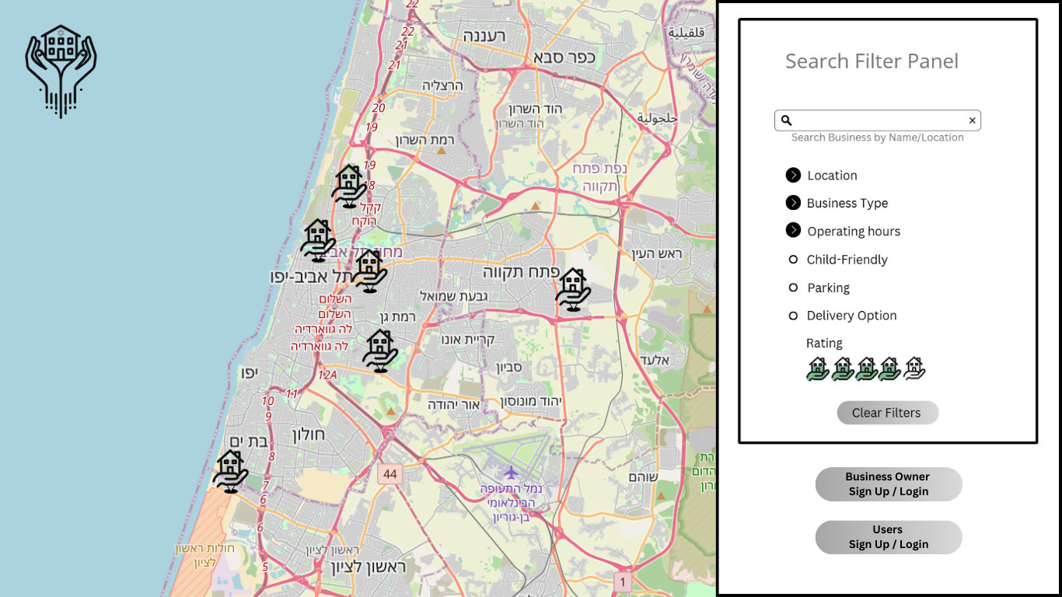

* 3.3.2 **Filters Panel**: Located on the side, allowing users to refine the displayed businesses according to:
  + Location (specific region or city).
  + Type of business (e.g., food services, retail, entertainment).
  + Operating hours (e.g., currently open).
  + Child-friendly businesses.
  + Additional criteria such as delivery availability or parking facilities.
  + Rating

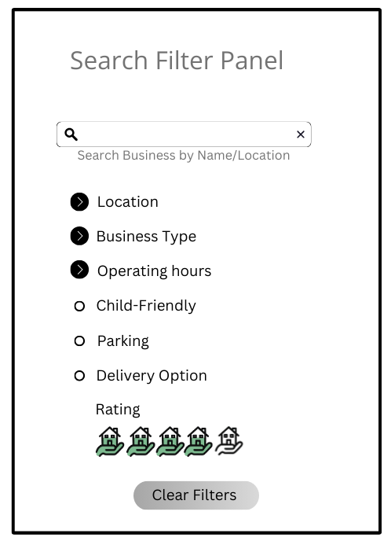

* 3.3.3 **Dynamic Map Integration:**
  + All businesses are displayed on an interactive map powered by OpenStreetMap and Leaflet.js.
  + Green icons represent currently open businesses, while red icons represent businesses currently closed.
  + Hovering over or zooming into the map displays additional details, such as the business name.
* 3.3.4 **Business Details Popup:** Clicking on a specific business icon on the map opens a pop-up window with detailed information:
  + Business name, address, and contact details.
  + Business type and hours of operation.
  + Child-friendliness, delivery options, and other specific criteria.
  + Link to the business’s website or contact for further actions.
  + Special Offers.

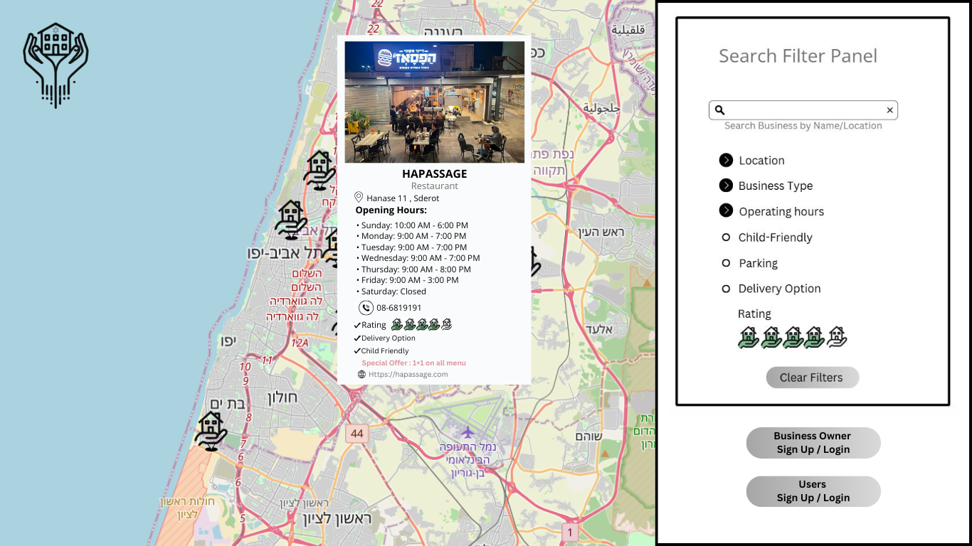

* 3.3.5 **Rating and Review Button:** Users who wish to rate a business can click the "Rate" button, which opens the registration/login prompt. After registering, users can submit ratings and comments. Ratings influence the display of businesses on the map, while written reviews are used for verification purposes only and do not appear publicly.
* 3.3.6 **Reset Filters Button:** Resets all filter options and displays the full list of businesses across all regions.
* **Application Activity Diagram**

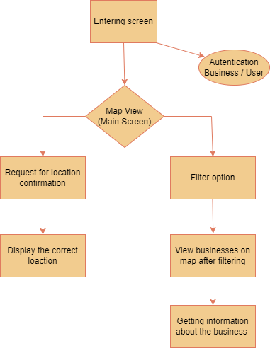

* **Business Activity Diagram**

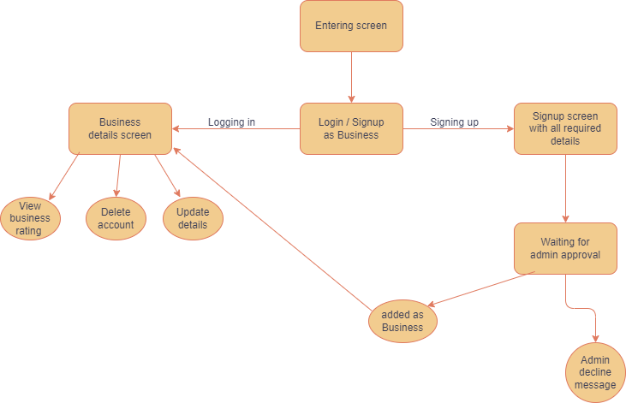

* **User Activity Diagram**

